**SMART TRAFFIC MANAGEMENT WITH IBM IOT**

TEAM MEMBER

**111421106017:HARIBALAN A**

**PHASE-1 DOCUMENT SUBMISSION**

**PROJECT NAME: TRAFFIC MANAGEMENT USING IOT**

**PROBLEM DEFINITION**:

The challenge in modern urban areas lies in the inefficient management of traffic, leading to congestion, safety hazards, and environmental degradation. Existing systems lack real-time data, hindering swift responses to accidents and changing traffic patterns. To address these issues, implementing an IoT-based Traffic Management System is crucial. By leveraging smart sensors and connected devices, this system aims to collect real-time data for accurate traffic analysis and predictions. Through dynamic traffic control mechanisms, such as adjusting signals based on live data, the system ensures optimal traffic flow. It also focuses on rapid accident detection, enabling automated rerouting to minimize disruptions. With user-friendly interfaces, this solution empowers commuters and traffic authorities alike, enhancing overall urban mobility while reducing environmental impact.

**OBJECTIVE:**

Implementing a Traffic Management System using IoT involves several key objectives. First, it focuses on real-time monitoring by employing smart sensors to collect live data on traffic conditions. This data is then analyzed using advanced algorithms to identify patterns and congestion points. The system incorporates dynamic traffic control mechanisms, enabling real-time adjustments to signals and lanes, ensuring smooth traffic flow. Additionally, it integrates accident detection sensors and cameras for swift response during emergencies, rerouting traffic efficiently. Predictive analysis based on historical and real-time data aids proactive traffic management. User-friendly interfaces provide commuters and authorities with timely information, empowering better decision-making. The system also addresses environmental concerns by monitoring and minimizing the impact of traffic-related pollution. Integrating IoT with public transportation enhances overall mobility. Scalability and adaptability are built-in, allowing for future expansion and continuous improvements. **DESIGN THINKING :**

**ABSTRACT:**

* Traffic management system is one of the major proportions of a smart city. With the rapid growth of population and rapid increase of vehicles across the whole country which further leads to the traffic Congestion which is usually seen on roads.
* Nowadays traffic congestion is a difficult issue to deal with as number of vehicles is increasing day by day. To tackle various issues of traffic on roads and to help authorities in proper planning, a smart traffic management system using the Internet of Things (IoT) is proposed in this paper.
* A simple, effective and less costly method is used to optimize traffic flow on roads and an algorithm is devised to manage various traffic situations efficiently and automatically.
* For this purpose, the system takes traffic density as input from 8 different sensors which are there in 4 lanes which manages traffic signals. Besides this manual control of this system using Wi-Fi is also used to prioritize the emergency vehicles such as ambulances and fire brigade vehicles during a traffic jam,
* so that we can open the specific lane with the remote using Wi-Fi. To show the effectiveness of this proposed traffic management system, a prototype is developed which optimizes the traffic having lesser cost and is very effective. And the real time data will also be visible in the mobile phone through application.

**MODULE 1: INTRODUCTION TO IOT**

It refers to a system consisting of inter related internet connected object that are able to collect and transfer data over a wireless network[6]. In this proposed system, it consists of ARDUINO, IR sensor, Wi-Fi modules. IR sensors will capture the density of each one so the traffic light time will be assigned on the basis of data

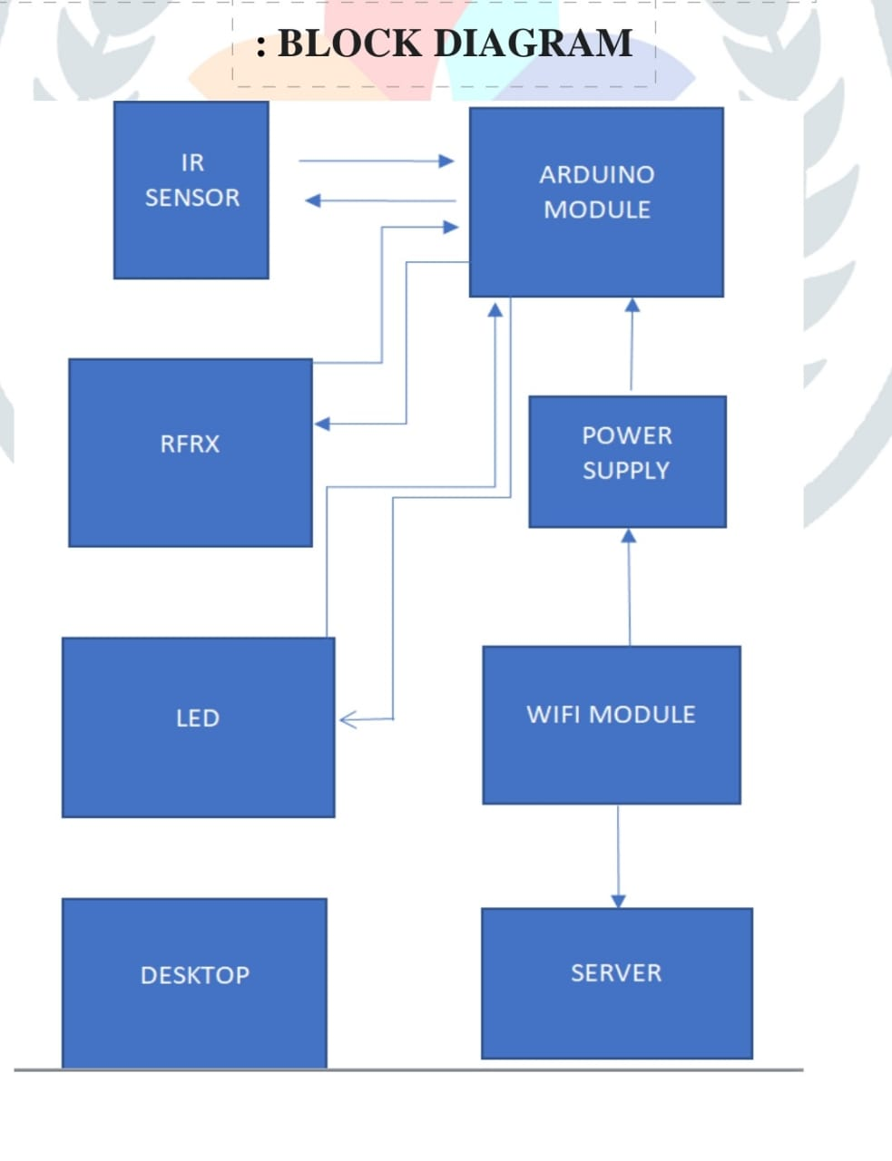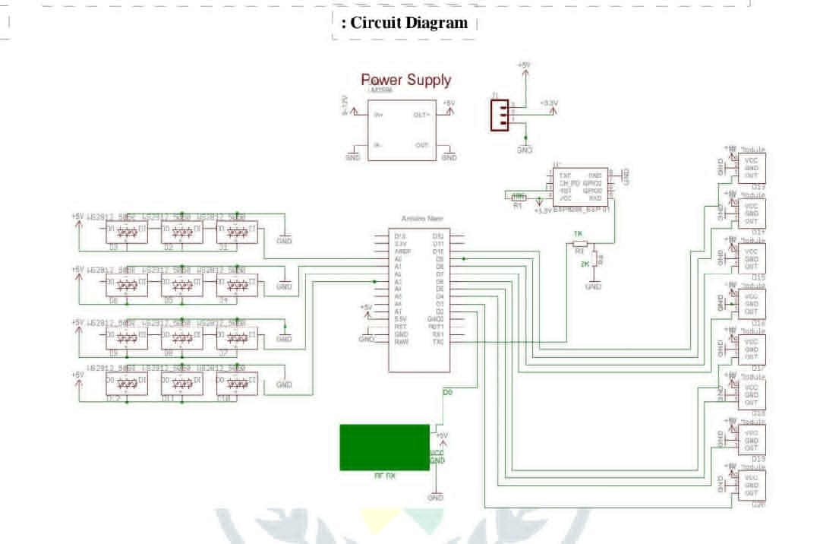

**MODULE 2:** **SYSTEM DESIGN AND ARCHITECHTURE**

**ARDUINO NANO:**An 8 bit Microchip AVR which is small, complete and bread board friendly board based on the Atmega328. It is the main CPU of our Project, in which we all the program will run

**POWER SUPPLY MODULE:** A power supply is a hardware component that provides power to any electrical device.

**IR SENSOR**: These sensors are used to detect the object through infrared rays. The rays which are thrown from the sensors are reflected back by the object by which it encountered and then after captured by these infrared sensors which further gets converted into electric signals. These sensors are put sideways for giving us the density of vehicles in the specific lane. Infrared sensors are used for signal control, detection of pedestrians in crosswalks and transmission of traffic information [8]. The basic disadvantages of infrared sensors are that the operation of the system may be affected due to fog; also installation and maintenance of the system is tedious

**WIFI MODULE**: It is used to give microcontroller access to your wife network

**RFRX MODULE** :It consists of RF transmitter and RF receiver; it is used for transmitting and receiving data

**LED :**Light bulbs are used for output and instruction for this system**.**

**BLYNK APP** :It is a mobile application for output and verification for real time data collected.

**WORKING METHODOLOGY:**

* There will 8 sensors across the 4 lanes with each lane having 2 sensors each, to give the data how much dense the lane is. If in case the entire lanes have less traffic then the system will work normally means the lanes sequence will be first A lane then B lane, then C lane and at last D lane.
* But in case if any of the lane gets more cars or gets denser then the other 3 lanes then that specific lane will open then the other with the second highest denser, then the same order continued to the other 2 lanes.
* If in case all the lanes have same number of vehicles then all the lanes will open in same order i.e. A, B, C, D. If in case there is an emergency vehicle that can be ambulance, fire brigade or an emergency scout team then we have a separate Wi-Fi module through which we can open can lane in which the emergency vehicle is arrived
* The proposed system will give output on the basis of density of the traffic lanes so there will be particular time assigned to the lanes for the passing of vehicles so it will lower down the traffic congestion and also in the case of emergency or any road block issue there will be option for that to continue the traffic in normal way and by using blynk app we can check that the system is working according to input or not.
* We can see from the image given about the output are coming for various lanes the density in lane one is 100% so other traffic lights are red and the traffic light of lane one will be green until the traffic is cleared so it will repeated for each lane and n the case of emergency on lane will be assigned and other lane will be blocked to control the case of emergency. The proposed system helps in better time based monitoring and thus has certain advantages over the existing system like minimizing number of accidents, reducing fuel cost and is remotely controllable etc.
* The system will be designed in such a way that it will able to control the traffic congestion as well as track the no of vehicles. And it can also be maintained very easily. The project is user friendly and can replace the existing project

**EXISTING SYSTEM:**

* The existing System is generally controlled by traffic police. The main drawback of our system which is controlled by traffic police is that the system is not smart enough to deal with the traffic congestion.
* The traffic police official can either block a road for more amount of time or let the vehicle on the other road pass by i.e. the decision making may not be smart enough and it entirely depends on the official’s decision.

**DISADVANTAGES OF EXISTING SYSTEM :**

• Traffic Congestion

• No means to detect traffic congestion

• Number of accidents are more

• It cannot be remotely controlled

• It requires more manpower

• It is less economical

• It is not efficient

**PROPOSED SYSTEM:**

The first and primary element of this system is the wireless sensor nodes consists of sensors. The sensors interact with the physical environment means vehicles presence or absence while the local server sends the sensors data to the central micro controller.

• The micro controller receives the signal sent from the sensors and computes which road or which lane has to be chosen based on the density of traffic or no of car

**ADVANTAGE OF PROPOSED SYSTEM:**

* Minimize number of traffic
* Reduce fuel cost and saves time and money.
* Low bugdet.
* Easy implementation.
* Remotely controllable.
* It is more efficient
* Requires less man power.

**FLOW CHART WITH ALGORITHM:**

**Case1**

1. Start

2. Check the vehicle Density

3. Vehicle density++

4. Is vehicle density<Threshold

5. Yes

6. Normal traffic

7. Give green signal to each Lane in a sequential manner

**Case2**

1. Start

2. Check the vehicle Density

3. Vehicle density++

4. Is vehicle density y <Threshold

5. No

6. Status =congestion

7. Compare the number of density in each lane

8. Open the lane with highest number of density

9. Remove current Lane from Comparison

10. Then start once again

**Conclusion:**

Our team members described about a traffic management system which is working on the basis of Iot and its embedded network and it is taking real time data as the input to track the traffic management system and giving output in terms of time assigned to traffic lights on the basis of density.The existing traffic system has not much option so in future this system can be used to control traffic in smart way by saving time, decreasing the accidents and also it can give real time traffic notification to people so they can choose the right lane or road to pass through. This system is also cost effective than the existing syste